**INSTRUCTIONS:**

**We are trying to understand more about how people with autism, or autistic tendencies, and people without autism search the web.**

* **For the search queries below please indicate what search terms you would use to search the web.**
* **There are no right or wrong answers.**
* **Some of the searches do not have an answer but please tell us how you would go about trying to search for the answer.**
* **If you would do many iterations of search, please indicate that below. Start with the one you are most likely to try.**
* **Please indicate as much as you can about your search process as possible. Use as much space as you need.**

**The second part asks you to complete an online questionnaire and report back the score on this sheet.**

**This should take approximately 20 minutes or less.**

**If you have any questions you can contact e.massand@bbk.ac.uk.**

EXAMPLE QUESTION:

You saw a man reading the paper today (you don’t know which paper it was), and the headline was vaguely about a new discovery about the solar system. What would you type into search on your favourite search engine to find out about the story?

EXAMPLE ANSWER:

*I could start by searching, ‘solar system and discovery and news and today’.*

*If that doesn’t work I could search, ‘todays paper and solar system’, or if I don’t find my answer there I could search ‘news’ and manually /visually sift the page for relevant info.*

What browser (Google Chrome, Firefox, Safari, …), and search engine (Google, Yahoo, Bing …) are you using to complete this task?

Browser:

Search Engine:

What is your age?

What is your highest level of education (already attained)?

1. You hear a song on the radio with the lyrics, ”Look at your children”, and you want to download it. What would you type into search on your favourite search engine to find out what song it was?
2. To find out about todays trending news stories, what search terms would you use?
3. To find out if it will rain tomorrow, what search terms/ queries would you use?
4. You’ve lost touch with an old school friend (you went to St. Mary’s School). What key words/queries would you use to find them?
5. How would you identify what this is using a search engine (pretend you don’t know what it is called). What key words/queries would you use?

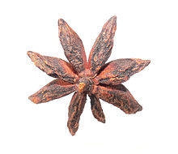

7. How would you find out the name of this famous person using a search engine? What key words/queries would you use?



8. Your friend and you can’t agree on how *Thandie Newton* pronounces her first name. How would you resolve this using a search engine?

9. How would you identify what breed this animal is using a search engine? What key words/queries would you use?

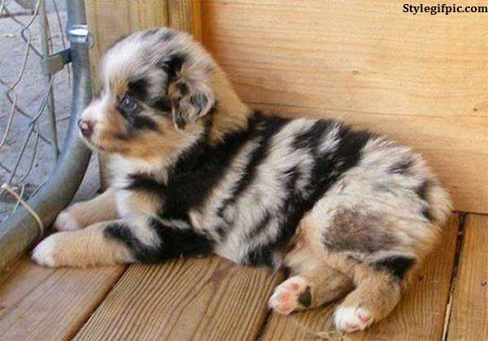

10. What would you search for to identify this pattern’s *name*, and which *country* it originates from?

11. How would you search for delay’s relating to your (imminent) flight to Paris?

**Part 2.**

<http://aspergerstest.net/aq-test/>

Go to the link above and report back your score on the Autism Quotient. There are 2 formats, please take ‘AQ Quiz Option 1’.

Your score here: